CO1: Design IIR digital filters using analog filter approximations, transformation techniques, and appropriate realization structures, and analyze their performance.
Experiment-1

- SIMULATION EXPERIMENT – 1
- SIMULATION EXPERIMENT – 2
- SIMULATION EXPERIMENT – 3
- SIMULATION EXPERIMENT – 4
- SIMULATION EXPERIMENT – 5

TOPICS COVERED:
The experiments in this unit cover Butterworth and Chebyshev Type-I IIR filter design, filter specifications and order determination, bilinear transformation, band-pass filter design, frequency response, pole-zero and stability analysis, and comparative performance evaluation.
SIMULATION EXPERIMENT – 1
1.Design, Realization and Performance Analysis of Butterworth IIR Low-Pass and High-Pass Digital Filters Using MATLAB
CO Mapping:CO1
Blooms Level K3-Apply
WK Level :WK3 Engineering Fundamentals (Applies IIR filter theory and Butterworth approximation)
➔ Objectives of this Experiment:
1. To design Butterworth IIR low-pass and high-pass digital filters for specified frequency requirements using MATLAB.
2. To obtain and verify the filter coefficients and determine the required filter order.
3. To plot and analyze the magnitude and phase responses of the designed filters.
4. To identify the cutoff frequency and examine the passband and stopband characteristics.
➔ Expected Outcome from this Experiment:
Students shall be able to:
1. Design Butterworth IIR low-pass and high-pass filters and obtain the corresponding numerator and denominator coefficients.
2. Determine the filter order and verify that the designed response follows the specified cutoff requirement.
3. Generate and interpret magnitude and phase response plots for both filters.
4. Identify the cutoff frequency and verify the passband/stopband characteristics from the MATLAB response.
4. Identify the cutoff frequency and verify the passband and stopband characteristics from the MATLAB response.
MATLAB with Signal Processing Toolbox.
➔ Objective linkage:
The experiment is structured so that each objective directly produces a verifiable output listed in the Output Parameter Table.
➔ Experimental Procedure:
1. Define the sampling frequency and the low-pass/high-pass passband and stopband specifications.
2. Normalize the digital frequency specifications with respect to the sampling frequency.
3. Determine the Butterworth filter order and normalized cutoff using the required MATLAB design functions.
4. Generate the low-pass and high-pass filter coefficients.
5. Evaluate the frequency response using the magnitude and phase response tools.
6. Record the cutoff frequency, passband/stopband behavior and filter order, and compare the obtained response with the design specification.
➔ INPUT PARAMETER TABLE – VALUES TO BE ENTERED
Sample Input
S.No | Input Parameter | Symbol / Setting | Value to Enter | Unit
1 | Sampling frequency (common to LPF & HPF) | Fs | 1000 | Hz
2 | Low-pass passband edge | Fp,LP | 100 | Hz
3 | Low-pass stopband edge | Fst,LP | 150 | Hz
4 | High-pass stopband edge | Fst,HP | 200 | Hz
5 | High-pass passband edge | Fp,HP | 250 | Hz
6 | Passband/stopband attenuation | Ap / Ast | Ap = 1; Ast = 40 | dB

%% Experiment 1: Butterworth IIR Low-Pass and High-Pass Filter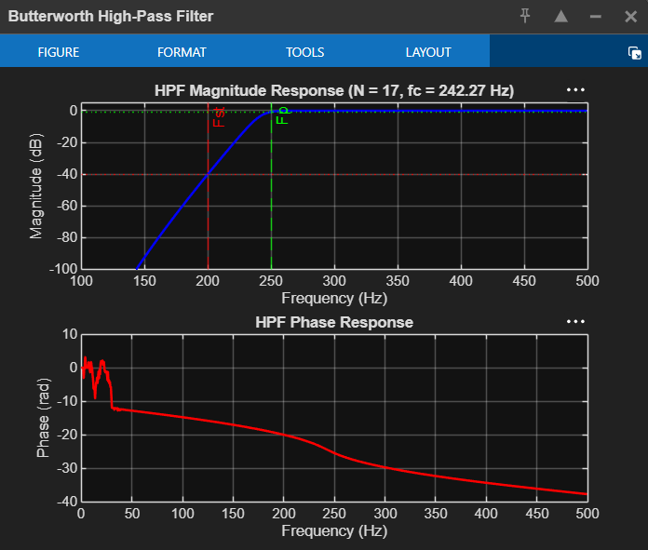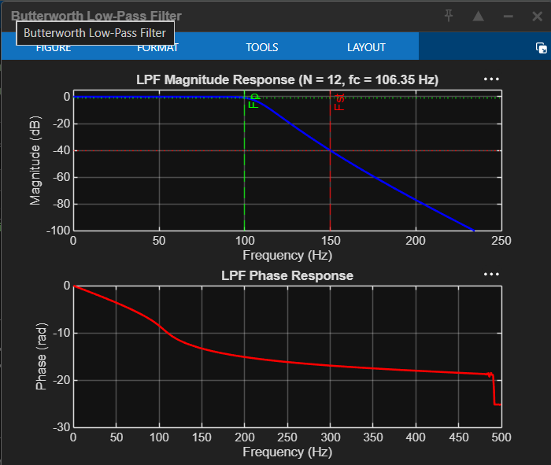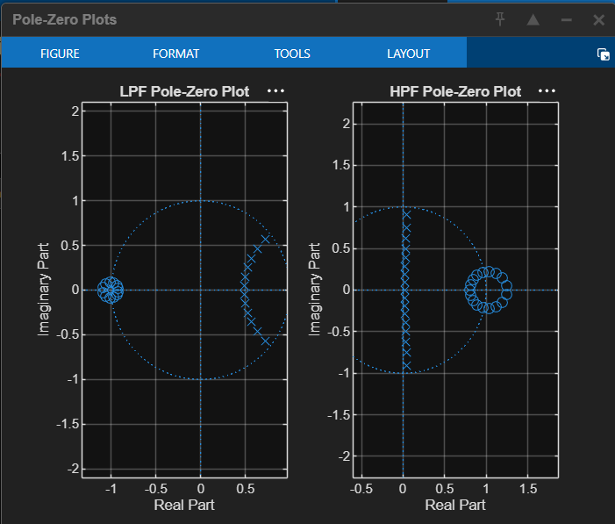
%% Experiment 1: Butterworth IIR Low-Pass and High-Pass Filter
clc; clear; close all;

%% 1. Input parameters
Fs = 1000; % Sampling frequency (Hz)
Fp_LP = 100; % LPF passband edge (Hz)
Fst_LP = 150; % LPF stopband edge (Hz)
Fst_HP = 200; % HPF stopband edge (Hz)
Fp_HP = 250; % HPF passband edge (Hz)
Ap = 1; % Passband ripple/attenuation (dB)
Ast = 40; % Stopband attenuation (dB)

%% 2. Normalize frequencies (w.r.t. Nyquist = Fs/2)
Wp_LP = Fp_LP /(Fs/2);
Ws_LP = Fst_LP/(Fs/2);
Ws_HP = Fst_HP/(Fs/2);
Wp_HP = Fp_HP /(Fs/2);

%% 3. Order and cutoff determination
[N_LP, Wn_LP] = buttord(Wp_LP, Ws_LP, Ap, Ast); % low-pass
[N_HP, Wn_HP] = buttord(Wp_HP, Ws_HP, Ap, Ast); % high-pass (Wp > Ws)

fc_LP = Wn_LP*(Fs/2); % -3 dB cutoff (Hz)
fc_HP = Wn_HP*(Fs/2);

%% 4. Filter coefficients
[b_LP, a_LP] = butter(N_LP, Wn_LP, 'low');
[b_HP, a_HP] = butter(N_HP, Wn_HP, 'high');

disp('--- Low-Pass Filter ---');
fprintf('Order N = %d, Normalized cutoff Wn = %.4f, fc = %.2f Hz\n', N_LP, Wn_LP, fc_LP);
disp('Numerator b ='); disp(b_LP);
disp('Denominator a ='); disp(a_LP);

disp('--- High-Pass Filter ---');
fprintf('Order N = %d, Normalized cutoff Wn = %.4f, fc = %.2f Hz\n', N_HP, Wn_HP, fc_HP);
disp('Numerator b ='); disp(b_HP);
disp('Denominator a ='); disp(a_HP);

%% 5. Frequency response
[H_LP, f] = freqz(b_LP, a_LP, 1024, Fs);
[H_HP, ~] = freqz(b_HP, a_HP, 1024, Fs);

%% 6. Magnitude response (dB)
figure;
subplot(2,1,1);
plot(f, 20*log10(abs(H_LP)), 'b', 'LineWidth', 1.5); grid on; hold on;
yline(-Ap, '--g'); yline(-Ast, '--r'); yline(-3, ':k');
xline(Fp_LP, '--g'); xline(Fst_LP, '--r');
title(sprintf('Butterworth LPF Magnitude Response (N = %d)', N_LP));
xlabel('Frequency (Hz)'); ylabel('Magnitude (dB)'); ylim([-100 5]);

subplot(2,1,2);
plot(f, 20*log10(abs(H_HP)), 'r', 'LineWidth', 1.5); grid on; hold on;
yline(-Ap, '--g'); yline(-Ast, '--r'); yline(-3, ':k');
xline(Fst_HP, '--r'); xline(Fp_HP, '--g');
title(sprintf('Butterworth HPF Magnitude Response (N = %d)', N_HP));
xlabel('Frequency (Hz)'); ylabel('Magnitude (dB)'); ylim([-100 5]);

%% 7. Phase response
figure;
subplot(2,1,1);
plot(f, unwrap(angle(H_LP))*180/pi, 'b', 'LineWidth', 1.5); grid on;
title('Butterworth LPF Phase Response');
xlabel('Frequency (Hz)'); ylabel('Phase (degrees)');

subplot(2,1,2);
plot(f, unwrap(angle(H_HP))*180/pi, 'r', 'LineWidth', 1.5); grid on;
title('Butterworth HPF Phase Response');
xlabel('Frequency (Hz)'); ylabel('Phase (degrees)');

%% 8. Verification of specifications
mag_dB = @(b,a,fx) 20*log10(abs(freqz(b,a,fx,Fs)));

fprintf('\n--- Verification ---\n');
fprintf('LPF gain at %d Hz (passband edge): %.3f dB (need >= -%d)\n', Fp_LP, mag_dB(b_LP,a_LP,Fp_LP), Ap);
fprintf('LPF gain at %d Hz (stopband edge): %.3f dB (need <= -%d)\n', Fst_LP, mag_dB(b_LP,a_LP,Fst_LP), Ast);
fprintf('HPF gain at %d Hz (stopband edge): %.3f dB (need <= -%d)\n', Fst_HP, mag_dB(b_HP,a_HP,Fst_HP), Ast);
fprintf('HPF gain at %d Hz (passband edge): %.3f dB (need >= -%d)\n', Fp_HP, mag_dB(b_HP,a_HP,Fp_HP), Ap);
fprintf('LPF gain at fc = %.2f Hz: %.3f dB (about -3 dB)\n', fc_LP, mag_dB(b_LP,a_LP,fc_LP));
fprintf('HPF gain at fc = %.2f Hz: %.3f dB (about -3 dB)\n', fc_HP, mag_dB(b_HP,a_HP,fc_HP));

%% 9. Pole-zero plot and stability check
figure;
subplot(1,2,1); zplane(b_LP, a_LP); title('LPF Pole-Zero Plot'); grid on;
subplot(1,2,2); zplane(b_HP, a_HP); title('HPF Pole-Zero Plot'); grid on;

fprintf('\nLPF stable? %d (max |pole| = %.4f)\n', all(abs(roots(a_LP))<1), max(abs(roots(a_LP))));
fprintf('HPF stable? %d (max |pole| = %.4f)\n', all(abs(roots(a_HP))<1), max(abs(roots(a_HP))));

%% 10. Realization (cascade / second-order sections)
[z1,p1,k1] = butter(N_LP, Wn_LP, 'low');
[sos_LP, g_LP] = zp2sos(z1,p1,k1);
[z2,p2,k2] = butter(N_HP, Wn_HP, 'high');
[sos_HP, g_HP] = zp2sos(z2,p2,k2);
disp('LPF SOS matrix:'); disp(sos_LP);
disp('HPF SOS matrix:'); disp(sos_HP);

